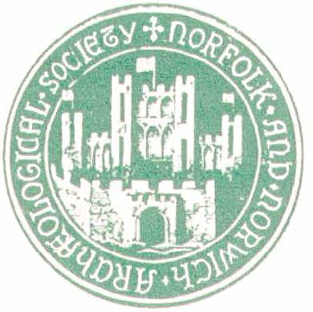
Norfolk and Norwich Archaeological Society

GRANT APPLICATION FORM

1. Applicant’s name:

Position: (e.g, academic post, independent researcher; museum curator, etc)

Qualifications relevant to Grant Application:

Other Qualifications:

2. Organisational affiliation (if applicable)

3. Contact name and address to which correspondence should be sent:
(preferable communication by email)

Telephone no.:
Email:

4.Title and Brief description of project
(up to 100 words):

5. Background information (history of the project, etc )
(up to 100 words):

6. Research aims of project:

7. Approximate scope of research
(eg GM collections, external collections, study visits, bibliographic research, field seasons):

8. Conservation Outcomes (if these are appropriate)

9. Education & Access Outcomes (what benefits will the project bring in terms of improving knowledge, education and access)

10. External partnerships and collaborations: (other organisations involved: the extent of their financial or material support)

11. Deliverables (e.g, inventory/cataloguing; database/web resources, publication, exhibition,
display etc):

12. Tasks and Duration (needed to achieve the above and approximate indication of the time required; planned dates for completion of the project):

13. Illustrations (to support the argument – maps, diagrams, pictures which may require financial support)

14. Bibliography (of material which has informed this project or which will need to be consulted)

15. Approximate costs: (please give your costs and the project budget total in as much detail
as possible – travel costs; photocopying; purchases; etc. If necessary this should be laid out
on a separate sheet and attached as an appendix to this application.)

16. TOTAL GRANT / Amount of support requested

17. Appendices (any supporting information you wish to include). Please list here any
such attached appendices which should include TWO LETTERS OF
RECOMMENDATION from individuals able to assess both or either your expertise for
undertaking the project and the likely value of the project as such.).

18. How will the NNAS contribution to the project be acknowledged? (Normally we
would expect the Society’s logo to appear in the preliminaries of any publication or
in association with any display. This should be accompanied by the wording “This
project was supported by funding from the Norfolk and Norwich Archaeological
Society”

I confirm that the details as set out in this application are correct to the best of my knowledge.

Signed .....................................................................

Date ...........................................

Name (please print) ...............................................................................................................

On behalf of a recognised organisation (if applicable) ....................................................................................................

Please send completed application form to:

The Hon.General Secretary

Norfolk and Norwich Archaeological Society
64 The Close
Norwich
NR1 4DH
Email: secretary@nnas.info
Telephone 01508 579 029

INFORMATION FOR APPLICANTS on our grant-making procedures

1. Initial applications are seen by the entire Council. If it so decides the Council may then appoint two expert Assessors to provide a detailed evaluation and recommendation. In order to expedite proceedings the Assessors are deputed if necessary to ask for further information from the applicant.

2. Normally the Assessors will make their recommendations in writing to the next meeting of the Council. The Council will vote on the recommendation at this meeting.

3. The Secretary will inform the applicant of the outcome of his/her application within five days of the meeting of the Council at which the decision is taken.

4. Members of the Council who may apply to it for funding will absent themselves from that part of the meeting at which their application is considered.

5. Applicants should be aware that the Council meets four times a year. The dates of meetings are advertised on the Society’s website. The timescale should be borne in mind when making applications. Funding will not be provided retrospectively.

6. Normally, the amount allocated will not exceed £500 in any one instance. However, in exceptional circumstances the Council may be prepared to consider applications for expenditure beyond this limit.

7. Following the completion of a project grant the applicant should supply the Treasurer with all relevant receipts and evidences of costs incurred.

8. The Council expects to receive a short report (around 500 words) on the completion of the project, or that part of a larger project which it has helped to fund. This should be submitted in digital form.

9. Where appropriate a copy of relevant publications arising wholly or in part from funding provided by the Society should be deposited in the Society’s library within two weeks of publication.

10. Applicants may be asked to provide a brief note on the project for inclusion in the Society’s Newsletter.

11. Where appropriate those who have received funding from the Society may be asked to contribute to a press release from the Society describing the project and its outcome.

