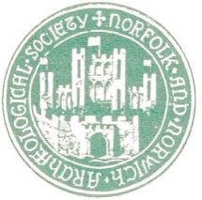
Norfolk and Norwich Archaeological Society
Charity No: 311116
Declaration of Interests Form
To be completed by all Trustees and Council Members. Declarations of interest will be reviewed at each meeting.
I ……………………………….. as a Trustee/Council Member* [*delete as appropriate] of the Norfolk and Norwich Archaeological Society have set out below my interests in accordance with the organisation’s conflicts of interest policy.
Category | Please give details of the interest and whether it applies to yourself or, where appropriate, a member of your immediate family, connected persons or some other close personal connection
Current employment and any previous employment in which you continue to have a financial interest.
Appointments (voluntary or otherwise) e.g. trusteeships, directorships, local authority membership, tribunals etc.
Membership of any professional bodies, special interest groups or mutual support organisations.
Investments in unlisted companies, partnerships and other forms of business, major shareholdings [charities may set a figure here, e.g. more than 1% or 5% of issued capital] and beneficial interests.
Gifts or hospitality offered to you by external bodies and whether this was declined or accepted in the last twelve months.
Do you use, or care for a user of the organisation’s services?
Any contractual relationship with the charity or its subsidiary
Any other conflicts that are not covered by the above.
To the best of my knowledge, the above information is complete and correct. I undertake to update as necessary the information provided, and to review the accuracy of the information on an annual basis. I give my consent for it to be used for the purposes described in the conflicts of interest policy and for no other purpose.
Signed:
Position:
Date:

