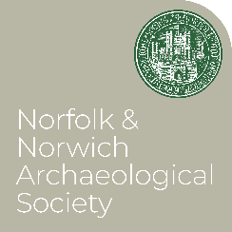
NNAS Summer Excursions

We have three excursions in the diary so far:

22 June The Railway Archaeology of Marriot’s Way
A free, gentle, 2 ¼ mile walk along Marriott’s Way as it runs from the site of Hellesdon Station to Norwich City Station at Barn Road, observing the surviving archaeology of the Midland and Great Northern Railway line. We will meet at Marlpit Community Centre at 10.30 am. Parking is available at Gunton Lane, or both ends of the route are easily accessible by Red Line buses on Dereham Road, if you prefer not to walk both ways.

BOOKING NOT REQURED

13 July Day visit to Kings Lynn
To celebrate the Festival of British Archaeology, we will tour Kings Lynn with Dr Paul Richards and Dr Clive Bond will give a short talk at True’s Yard Fisherfolk Museum, as well as visits to St Nicholas Chapel, Kings Lynn Minster and more.
Travel options: after low take up in the past, we will not hire a coach for this visit. Instead, to travel as a group, meet at Norwich Bus Station at 8.30 AM to join the 8.40 Excel C Service. Otherwise, meet the group at Kings Lynn Bus Station at 10.15. We will return on the 16.10 service.
Cost £12.50 includes a buffet lunch at True’s Yard.

BOOK HERE

31 August Romanesque churches of the Waveney Valley led by Dr Brendan Chester-Kaldwell
Visiting several very interesting churches, this tour explores the religious architecture of the late Saxon and Norman periods, and the ways in which different liturgical usages and theological traditions influenced their design.
We encourage car-sharing for this excursion! There will be a small fee of £6.00 to cover donations to the churches we visit, and a detailed itinerary will be supplied in due course.

BOOK HERE

