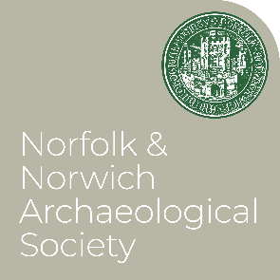
NNAS Lecture Dates 2025-26

All lectures take place on Saturdays at 2.15pm, doors open at 1.45. Usual venue Town Close Auditorium, Norwich Castle Museum.

2025

Sept 20 Heritage Open Days Event- At Hungate Medieval Art, Princes St Norwich.
Celebrating the Plunkett Prize
Join NNAS members, and the competition panel, at Hungate for a free talk on the inspiration and context of our new competition, The Plunkett Prize Photographic Competition. Includes a chance to view an exhibition of the shortlisted images.
Book online access
Oct 4 Defending Second World War Thetford: Not just Dad’s Army
Chris Kolonko-Weet, MOLA (Formerly Home Front Legacy Officer, CBA.)
Book online access

Nov 8 Following in Ancient Footsteps: Rediscovering the earliest technologies in Norfolk
Dr James Dilley, AncientCraft.
Book online access

Dec 6 Norwich Castle Keep Restored
Dr Tim Pestell, Senior Curator of Archaeology NMS. (Joint lecture with NAHRG)
Book online access

2026
Jan 3 There’s something about Diss: an exploration of its vernacular buildings and discussion on the evolution of the town.
Jess Johnston, Heritage Consultant.
Book online access

Feb 7 The Archaeology of Hornsea 3
Patrick Moan, Oxford Archaeology. (Joint lecture with The Prehistoric Society)
Book online access

Mar 7 Norwich, Northumbria, and Norway: Anglo-Scandinavian links and two lost city churches The Sue Margeson Memorial Lecture 2026
Dr Brian Ayers, Honorary Associate Professor, UEA.
Book online access
Lectures are free and open to all. There is no need to pay museum admission. Non-members are asked to make a donation if they can. The Museum café is open until 4pm.
All lectures are also live streamed via Microsoft Teams. You do not need to have Teams installed to use this, and can watch from any computer or smartphone. Please book in advance on the link for each individual talk, and a link will be emailed to you. We just ask that you remember to cancel your place if you will not be using it, so that others can participate.

