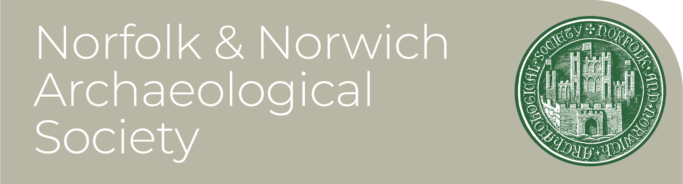
Patron: His Majesty The King

Papers for 180th Annual General Meeting of
The Norfolk and Norwich Archaeological Society

To be held on Saturday 3rd October, 1.00PM,
at Norwich Castle Museum, or by Teams.
To register for digital attendance click HERE

CONTENTS

Page

1-2 Agenda for the 180th AGM

3 Notes on the Agenda

4-6 Minutes of the 179th AGM, held on Saturday 6th December 2025.

7-18 Trustees’ Annual Report for the year ended 31st December 2025, including Financial Review

19-20 Accounts for the year ended 31st December 2025

20-23 Notes to the Accounts

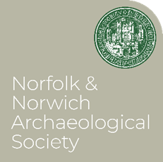
AGENDA For the 180th Annual General Meeting of The Norfolk and Norwich Archaeological Society. To be held on Saturday 3rd October, 1.00PM at Norwich Castle Museum, or online HERE

AGENDA

1. Apologies
2. Minutes of the 179th (2025) AGM
3. Matters Arising
4. Proposal to Adopt the Trustees Annual Report for 2025 (Appended, to be taken as read.)
5. Proposal to Adopt the Annual Accounts for 2025 (Appended, to be taken as read.)
6. Election of Trustees
(i)The Officers, consisting of the President, Heather Wallis, Hon. Treasurer, Mrs Karen Watling and Hon. Gen. Secretary Ms Sophie Cabot.
(ii) Re-election of the trustees, being willing to serve for a further term: Dr Andrew Hutcheson, Ms Heather Wallis, Dr Clare Haynes, Dr Andrew Rogerson, Ms Sophie Cabot, Mr Trevor Nuthall, Dr Victor Morgan, Dr Paul Spoerry, Karen Watling and Tim Pestell.
(iii) The election of new Trustees: Nominations Open
7. Re-election of Vice-Presidents
(i) to propose the re-election of the following Vice-Presidents: Dr Andrew Hutcheson, Dr B S Ayers; Mr R Bellinger; Ms Sophie Cabot, Mr A Fakes, Professor E Fernie; the Ven Dr W M Jacob; Mrs H. Paterson
8. Election of the Honorary Officers
(i) to propose the re-election of the following Honorary Officers, being willing to serve for a further term:
Honorary General Secretary: Ms Sophie Cabot
Honorary Treasurer: Ms Karen Watling
Honorary Editor of Norfolk Archaeology: Dr Sue Anderson
Honorary Librarian: Mrs Judy M. Sims
Honorary New Members Secretary: Mr Alistair Graham Kerr
Honorary Publicity Secretary and Young Archaeologists’ Club Organiser: Ms Sophie Cabot
(ii) The election of new Honorary Officers:
Honorary Newsletter Editor: Mr Josh White
Honorary Activities Secretary: Nominations open
Honorary Lectures Secretary: Nominations Open
Convenor of Editorial Committee: Nominations open
NB: Please send nominations to office@nnas.info ideally not later than seven days before the meeting, supported by a proposer and seconder and with the written agreement of the person nominated. Informal suggestion may also be made, and the Secretary will approach the candidate, but in this case you should be willing to act as proposer.
9. Thanks of the Society to those Volunteers standing down from appointed roles at this meeting: Roger Bellinger, Michael Pittaccio and Dr Lorna Richardson
10. Re-appointment of the Independent Examiner of Accounts – Sexty & Co.
11. Confirmation of adoption of The Seven Principles of Public Life, known as the ‘Nolan Principles’. (See notes below)

12. Any Other Business

Notes on the Agenda:

Item 11. The Seven Principles of Public Life (Known as the ‘Nolan Principles’)
These arose in the mid-nineteen-nineties from the work of what became known as the Nolan Committee on Standards in Public Life. Although originally formulated with a view to those holding office within the organs of state and ancillary bodies they have come to be applied more widely as ‘good practice’ for all of those holding office in voluntary organisations such as the Norfolk and Norwich Archaeological Society. Therefore, upon their election or appointment, Trustees and Members of the Advisory Council of the NNAS are asked to agree to adhere to these principles.
They are:

1. Selflessness: Holders of public office should act solely in terms of the public interest.
2. Integrity: Holders of public office must avoid placing themselves under any obligation to people or organisations that might try inappropriately to influence them in their work. They should not act or take decisions in order to gain financial or other material benefits for themselves, their family, or their friends. They must declare and resolve any interests and relationships.
3. Objectivity: Holders of public office must act and take decisions impartially, fairly and on merit, using the best evidence and without discrimination or bias.
4. Accountability: Holders of public office are accountable to the public for their decisions and actions and must submit themselves to the scrutiny necessary to ensure this.
5. Openness: Holders of public office should act and take decisions in an open and transparent manner. Information should not be withheld from the public unless there are clear and lawful reasons for so doing.
6. Honesty: Holders of public office should be truthful.
7. Leadership: Holders of public office should exhibit these principles in their own behaviour and treat others with respect. They should actively promote and robustly support the principles and challenge poor behaviour wherever it occurs.
Item 12.
It would be extremely helpful if AOB matters could be received at secretary@nnas.info before the meeting. Items arising during the meeting can of course be tabled in real time.

Following the meeting there will be a break before the October lecture, which will commence at 2.15PM.
Please join us for 180 Years of the Norfolk and Norwich Archaeological Society with Sophie Cabot
Book online access HERE

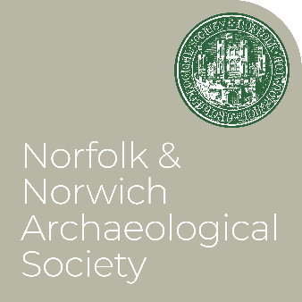
MINUTES of the 179th Annual General Meeting of
The Norfolk and Norwich Archaeological Society, held on Saturday 6th December 2025 at 1.00PM, at Norwich Castle Museum and online by Teams.

The meeting was quorate in the room, with further members attending online. Votes were taken by show of hands, and all decisions were by unanimous consent unless recorded otherwise.

The President, Dr Annie Grant, in the Chair, introduced the meeting by welcoming members, and introducing the agenda.

MINUTES
Agenda Item Decision

1. Apologies, received from: Dr Victor Morgan, Dr Keith Robinson, Charles Clarke, Dr Lorna Richardson

2. Minutes of the 2024 AGM
The Chair asked if the minutes of the previous meeting, which had been circulated, could be taken as read. Agreed
The Chair then signed the Minutes.

3. Matters Arising
The Chair asked if any member had any matters arising from the minutes, not otherwise addressed on the Agenda. None were raised.

4. The Chair asked the Hon.Gen.Sec if she had any comments to make on the Annual Report, as circulated. She had none, but asked if there were any from the floor. None raised.
Proposal to Adopt the Trustees Annual Report for 2024:
Agreed

5. The Chair asked if anyone wished to raise any questions arising from the Annual Accounts for 2023 as circulated, or the proposed increase in subscriptions for 2025. No questions raised.
Proposal to Adopt the Annual Accounts for 2023,
Proposal to Increase the Subscription to new rates of:
£29 for Individual members (currently £21)
£35 for Household members and all Corporate and Overseas members (currently £25) and
remove the previous £5 rate for junior membership
Agreed

6. Election of Trustees
Dr Annie Grant tendered her resignation for reasons of ill health and handed the Chair to the Honorary Secretary, Sophie Cabot.

The Honorary Secretary chaired the election of the new president, Heather Wallis.
Agreed

The new President took the Chair and read the list of Officers and Trustees willing to be selected for a further term, as circulated.
(i)The Officers, consisting of Hon. Treasurer, Karen Watling and Hon. Gen. Secretary, Sophie Cabot.

(ii) Re-election of the trustees, being willing to serve for a further term: Dr Andrew Hutcheson, Ms Heather Wallis, Dr Clare Haynes, Dr Andrew Rogerson, Mrs Margaret Gooch, Ms Sophie Cabot, Mr Roger Bellinger, Mr Trevor Nuthall, Dr Victor Morgan, Tim Pestell,
Proposal to re-elect the officers and Trustees as listed
Agreed

(iii) The election of new Trustees: Dr Paul Spoerry, Mr Michael Pittaccio, Dr Lorna-Jane Richardson
Proposal to elect the above to join the trustees
Agreed
(Addendum: Dr Lorna-Jane Richardson has been unable to take up this office, due to ill health.)

7. Re-election of Vice-Presidents
The president handed the Chair to the Hon.Gen.Sec for the following votes:

(i) (iii) to propose the re-election of the following Vice-Presidents: Dr Andrew Hutcheson, Dr B S Ayers; Mr R Bellinger; Ms Sophie Cabot, Mr A Fakes, Professor E Fernie; the Ven Dr W M Jacob; Mrs H. Paterson, Mr Michael Begley.
Proposal to re-elect the Vice Presidents as listed above
Agreed

8. Election of the Honorary Officers
The President then retook the Chair for (i) the re-election of the following Honorary Officers, being willing to serve for a further term:

General Secretary: Ms Sophie Cabot
Editor of Norfolk Archaeology: Dr Sue Anderson
Librarian: Mrs Judy M. Sims
Membership Secretary: Mr Alistair Graham Kerr
Publicity Secretary and Young Archaeologists’ Club Organiser: Ms Sophie Cabot
Assistant Treasurer: Roger Bellinger

And (ii) the election of new Honorary Officers:
Newsletter Editor, Michael Pittaccio
Lectures Secretary: Dr Lorna-Jane Richardson
(Addendum: Dr Lorna-Jane Richardson has been unable to take up this office, due to ill health.)

Activities Secretary: Nominations open
Convenor of Editorial Committee: Nominations open

Proposal to elect the new Honorary Officers listed above, and seek nominations for the vacant posts
Agreed

9. Re-appointment of the Independent Examiner of Accounts
Proposal, that Sexty & Co. be reappointed
Agreed

10. Adoption of The Seven Principles of Public Life (Known as the ‘Nolan Principles’)
These having been circulated, the President asked for any comments on their adoption by the Trustees and Officers
Proposal, that the Trustees and Officers, as well as the Hon Secs of the Society, adopt the Nolan Principles.
Agreed

11. Any Other Business
It was proposed from the floor that whenever possible new Trustees should be introduced in the Newsletter, and that the Editor be asked to facilitate this. Agreed

The meeting closed at 1.30pm

Following the meeting, members enjoyed a lecture “Norwich Castle Keep Restored” by Dr Tim Pestell.

ANNUAL REPORT AND FINANCIAL STATEMENTS

FOR THE YEAR ENDED 31ST DECEMBER 2025

The County Archaeological Society for Norfolk since 1846

Registered Charity Number: 311 116

Registered Office: 64 The Close Norwich, NR1 4DH

Bankers
Barclays Bank Plc
5/7 Red Lion Street
Norwich, NR1 3QH

Building Society
Leeds Building Society
6-7 Guildhall Hill
Norwich, NR2 1JG

Solicitors
Leathes Prior
74 The Close
Norwich, NR1 4DR

Insurance Brokers
Towergate Insurance
Towergate House,
5 Airport West,
Lancaster Way,
Leeds, LE19 7ZA

Investment Managers
Rathbones (Incorporating Investec Wealth & Investment UK)
30 Gresham Street,
London, EC2V 7QN

Independent Examiner for Accounts
Ian Barlow, Sexty & Co
124 Thorpe Road
Norwich, NR1 1RS

- 2025 AT A GLANCE

During 2025 the Norfolk and Norwich Archaeological Society (the Society):

- Launched the inaugural Plunkett Prize, celebrating and encouraging the taking of photographic images as a historical record.
- Published Volume 3 of the second series of the Norfolk Archaeology journal.
- Delivered six public lectures with audiences attending both in person and on-line.
- Organised three summer excursions, all of which were well supported.
- Awarded £6,320 in grants supporting archaeological research, heritage projects, and the purchase by the Norfolk Museums Service of a rare medieval coin hoard.
- Completed an independent strategic review which will lead to significant improvements in governance, administration and financial management.
- Entered its 180th anniversary year in 2026 in a strong financial position with unrestricted funds of £785,382.

- TRUSTEES AND OTHER VOLUNTEERS

The Society is governed by a Board of Trustees, supported by Honorary Officers, Vice Presidents, and members of the Advisory Panel who contribute specialist knowledge and experience. Unless otherwise stated, those listed below served during the year ended December 2025.

Trustees

Ms Heather Wallis - President (appointed at December 2025 AGM)
Dr Annie Grant - President (resigned December 2025)
Ms Sophie Cabot - Honorary General Secretary, Publicity Officer, & Norwich Young Archaeologists Club Organiser
Ms Karen Watling - Honorary Treasurer
Mr Roger Bellinger - Honorary Assistant Treasurer
Dr Clare Haynes - Honorary Newsletter Editor & Convenor, Publications Committee
Dr Lorna Richardson
Dr Andrew Hutcheson
Dr Paul Spoerry
Dr Victor Morgan
Mr Trevor Nuthall
Mr Michael Pittaccio
Dr Andrew Rogerson
Mrs Margaret Gooch (resigned July 2025)
Dr Tim Pestell (appointed December 2025)

Other Officers

Dr Sue Anderson - Honorary Editor, Norfolk Archaeology
Mrs Judy Sims – Honorary Librarian
Mr Alistair Graham Kerr – Honorary Membership Secretary
Keith Robinson – Honorary Lecture Secretary

Vice Presidents

Mr B S Ayers, Mr R Bellinger, Mr M R Begley, Ms S Cabot, Mr A Fakes, The Ven. Prof W M Jacob, Prof E C Fernie, Mrs H Paterson, Dr A Hutcheson

Members of the Advisory Panel

Mr S Ashley, Prof S C Kaner, Prof W Bowden, Dr T J Pestell, Dr J Gregory, Mr D J King, Mr D Leak, Mr T Bradstreet, Mrs Margaret Gooch

- ABOUT THE SOCIETY: ITS AIMS AND GOVERNANCE

The Norfolk and Norwich Archaeological Society was founded in 1846 and is one of the United Kingdom's oldest archaeological societies. It is governed by its constitution and is a registered charity under the Charities Act 2011.

Aims and Objectives

The Society exists to advance the education of the public through the study of archaeology in Norfolk. In support of this charitable purpose, the Society seeks to:

- Promote the study of the history, architecture, and antiquities of Norfolk.

- Collect, preserve, and publish information relating to the county’s archaeology, history, and historic environments.

- Encourage archaeological research, field work and investigation by individuals and organisations, and

- Promote the protection and conservation of Norfolk's archaeological and historic heritage.

The Trustees review the Society's activities throughout the year to ensure they continue to support these charitable objectives and provide clear public benefit.

Governance

The Society is led by a Board of Trustees elected by the membership at the Annual General Meeting. Where appointments are made between Annual General Meetings, they are confirmed by members at the next AGM.

Heather Wallis was elected president at the Society's AGM on 6th of December 2025, succeeding Dr Annie Grant, who resigned due to ill health. The trustees wish record their grateful thanks to Dr Grant for her service.

Heather is an archaeologist with over 40 years’ experience and currently works as a freelance archaeological consultant across Norfolk and Suffolk. Most recently she led the archaeological works undertaken at Norwich castle museum in advance of the reopening of the restored castle keep in 2025.

Each Trustee has completed a trustee eligibility declaration, and the Society maintains trustee indemnity insurance through Towergate Insurance.

The Trustees met on 4 occasions during 2025: 15 January, 16 April, 16 July and 15 October. In addition, subcommittees, and working groups, including the Editorial and Events groups, met throughout the year as required.

Advisory Committee members are appointed by the Trustees by invitation, to provide specialist advice on areas of archaeology and history relevant to the work of the Society. They have no voting rights.

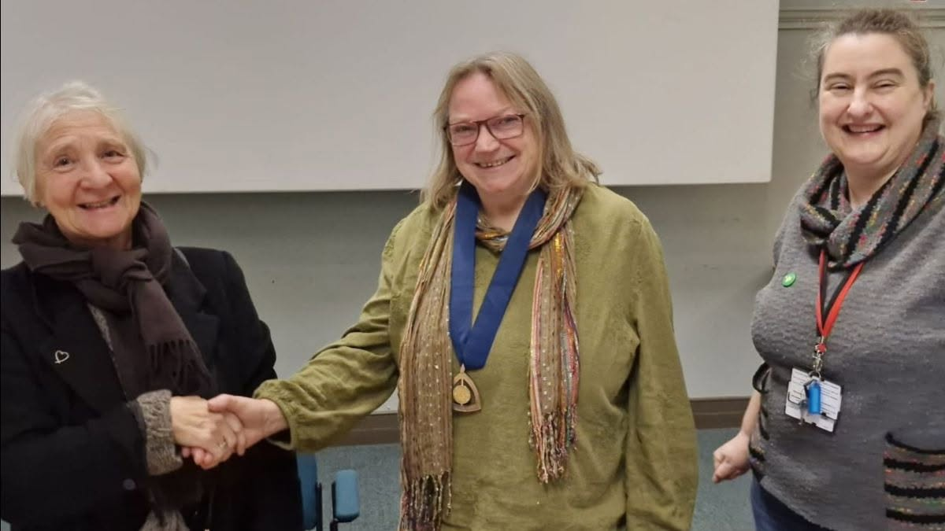
Newly elected President Heather Wallis (centre) with outgoing President Dr Annie Grant (left) and Hon. Secretary Sophie Cabot (right)

Trustees’ responsibilities and recruitment

The Trustees are responsible for the overall governance and strategic direction of the Society. They are responsible for safeguarding its assets, ensuring that its funds are applied solely in furtherance of its charitable purposes, and ensuring that the Society complies with charity law and all other relevant legal and regulatory requirements. They have resolved to be bound by the Seven Principles of Public Life (the ‘Nolan Principles’) in so doing.
In preparing the Annual Report and Financial Statements, the Trustees are required to:
- Keep adequate accounting records that are sufficient to show and explain the Society’s transactions and disclose with reasonable accuracy at any time the financial position of the Society.
- Select suitable accounting policies and then apply them consistently.
- Make judgements and accounting estimates that are reasonable and prudent.
- State whether applicable UK accounting standards have been followed, subject to any material departures disclosed and explained in the Statement of Accounts.
- Prepare the financial statements on a going concern basis unless circumstances dictate that to do so would be inappropriate.
- Take special care when investing the funds of the charity or borrowing funds for the charity.

The Society seeks to maintain a balanced Board of Trustees with a broad range of skills and experiences reflecting its charitable activities. Trustees and Honorary Officers are appointed or elected in accordance with the Society's Constitution.

As part of the wider programme of organisational improvements described later in this report, Trustees will strengthen governance arrangements by developing role descriptions and by reviewing recruitment and induction arrangements for new Trustees and volunteers.

All Trustees, officers and committee members serve in a voluntary capacity. During the reporting period the Society employed a freelance consultant, Mrs Rachel Kirk, to undertake a strategic review of the Society and subsequently appointed her on a part-time basis to provide administrative support.

Policies and Risk Management

The Trustees regularly review the Society's governance arrangements and maintain a suite of policies to support the effective operation of the charity. These include policies covering:

- Health and Safety
- Equality, Diversity and Inclusion
- Safeguarding (children's and vulnerable adults)
- Volunteers
- Conflicts of interest
- Trustee Code of Conduct and Declarations of Interest
- Risk Management

Public Benefit

The Trustees confirm that they have complied with the duty in section 17 of the Charities Act 2011 to have due regard to the Charity Commission’s guidance on public benefit when planning and delivering the Society’s activities.

The Society advances public education by promoting the archaeology, history and historic environment of Norfolk through its publications, lectures, excursions, grants programme, library, support for the Young Archaeologists Club, and digital communications. These are activities are open to members and, wherever practicable, to the wider public, ensuring that the Society’s resources and expertise are shared as widely as possible.

The Trustees are satisfied that the Society's activities throughout 2025 provide clear and demonstrable public benefit in furtherance of its charitable purposes.

The Society relies on the commitment and expertise of its volunteers, whose contribution enables it to deliver a wide programme of activities for the benefit of its members and the wider public.

Annual General Meeting

The Society’s 179th Annual General Meeting was held on Saturday 3rd of October 2026 at Norwich Castle Museum. Members received and approved the Trustees’ Annual Report and Financial Statements for the year ended 31st of December 2025 together with the report of the Independent Examiner of Accounts.

- MEMBERSHIP AND ACTIVITIES

The Society delivered a varied programme of activities throughout 2025 in support of its charitable objectives. These included public lectures, excursions, publication of Norfolk Archaeology and the Society newsletter, digital communications, support for Norwich Young Archaeologists Club, management of the Society’s specialist library, the award of grants to archaeological projects, and the successful launch of the inaugural Plunkett Prize photographic competition. Details are given in the paragraphs that follow.

Together, these activities help to promote the understanding, enjoyment and conservation of Norfolk’s archaeological and historic heritage whilst increasing opportunities for public participation.

Membership

Membership remains central to the Society's work, providing both financial support and a community of people committed to promoting the archaeology, history and historic environment of Norfolk.

 | Individual | Household | Corporate | Overseas | TOTAL
2025 | 263 | 97 | 43 | 5 | 408
2024 | 268 | 75 | 30 | 10 | 383
2023 | 278 | 106 | 26 | 23 | 433

The Trustees will continue to review membership trends and explore opportunities to broaden membership and encourage greater participation in the Society's activities.

Lecture programme

The Society's lecture programme remains one of its principal means of advancing public understanding of Norfolk's archaeology and history. Six lectures were delivered during the calendar year 2025, attracting audiences both in person at the Town Close Auditorium, Norwich Castle Museum, and online via Zoom.
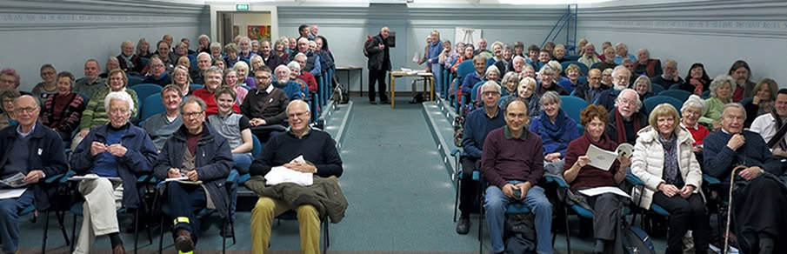
Members and visitors attending one of the Society’s public lectures at the Town Close Auditorium at Norwich Castle Museum

Where possible, lectures were recorded to support the Society's longer-term aim of developing a digital archive of talks, extending access to members and the wider public who are unable to attend in person.

The 2025 programme comprised:

- 4 January - Dr Sue Anderson, Editor of Norfolk Archaeology, Tradition and innovation: pots and potters of Late Saxon to Medieval East Anglia.

- 1 February – Lily Hodges, Cotswold Archaeology, Excavations at a new Anglo-Saxon site in Norfolk.

- 1 March - Sue Margeson Memorial Lecture: Prof Christopher Scull (Cardiff University and University College London), Rendlesham Revealed: exploring an East Anglian Royal Centre.

- 4 October Chris Kolonko-Weet, MOLA (Formerly Home Front Legacy Officer, (CBA) Defending Second World War Thetford: Not just Dad’s Army.

- 8 November - Dr James Dilley, AncientCraft, Following in Ancient Footsteps: Rediscovering the earliest technologies in Norfolk, presented jointly with Prehistoric Society.

- 6 December – Dr Tim Pestell, Senior Curator of Archaeology, Norfolk Museums Service, Norwich Castle Keep Restored, presented jointly with the Norfolk Archaeological and Historical Research Group (NAHRG).

Excursions

Summer excursions continued to provide members with opportunities to explore Norfolk’s archaeology, architecture and historic landscape through guided visits led by experts in their field. The programme complements the Society's lecture series by enabling participants to experience the county's heritage first hand.
The 2025 programme comprised:

- 7 June - Maud Wherry: a guided visit exploring the history of Norfolk’s last surviving clinker-built trading wherry.

- 16 July - A guided tour of the Britons Arms in Norwich, one of Norwich’s most significant medieval buildings.

- 30 August - Early English and Decorated churches of the Waveney Valley led by Dr Brendan Chester-Kaldwell.

The Trustees continue to seek a volunteer Activities Officer to help develop and expand the Society's programme of excursions and other member activities.

2025 Plunkett Prize

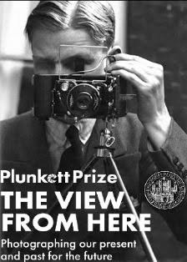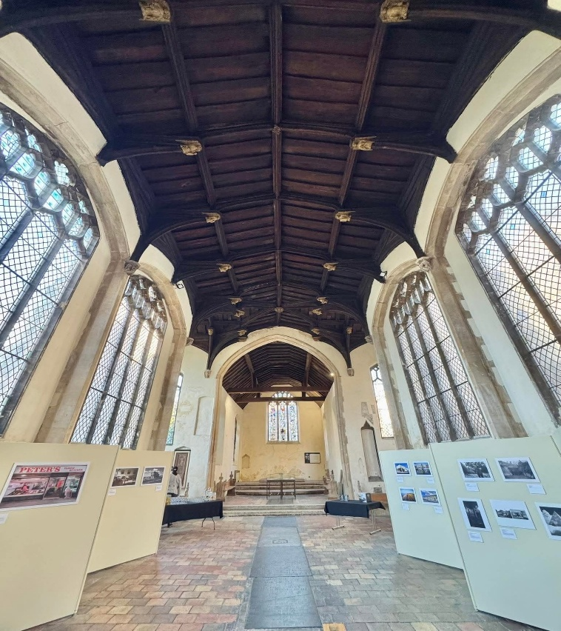
George Plunket featuring on the NNAS publicity for the event (left) and the exhibition of shortlisted entries at St Peter Hungate, Norwich (right)

One of the highlights of 2025 was the successful launch of the Society’s inaugural Plunkett Prize, a new biennial photographic competition celebrating Norfolk's historic environment and encouraging people to explore and record the county's rich archaeological and architectural heritage.

Named in honour of George Plunkett (1913 to 2006), whose remarkable photographic record of Norfolk has become an invaluable resource for historians, archaeologists and local communities, the competition sought to inspire a new generation to document today's landscape for the benefit of future researchers.

The competition, entitled The View from Here: Photographing our Present and Past for the Future, was open between 1st of June and 31st to July 2025. Interest in the competition was very strong, and with close to 300 entries. 26 of the entries were shortlisted, and 6 prizes awarded in two categories:

- Adult category - first prize £500 (Adrian Richmond) runner- up £250 (Joseph Morris and Mike Gorski).
- Under 16 category - first prize Canon EOS R100 camera (Emilia Wright); runner- up Instax camera).

The prizes were awarded at the opening of the Plunket Prize exhibition, on 13th September, in the presence of the Lord Mayor Of Norwich, Councillor Paul Kendrick and the Sheriff of Norwich, Stuart Wright, & the Sheriff’s Lady.

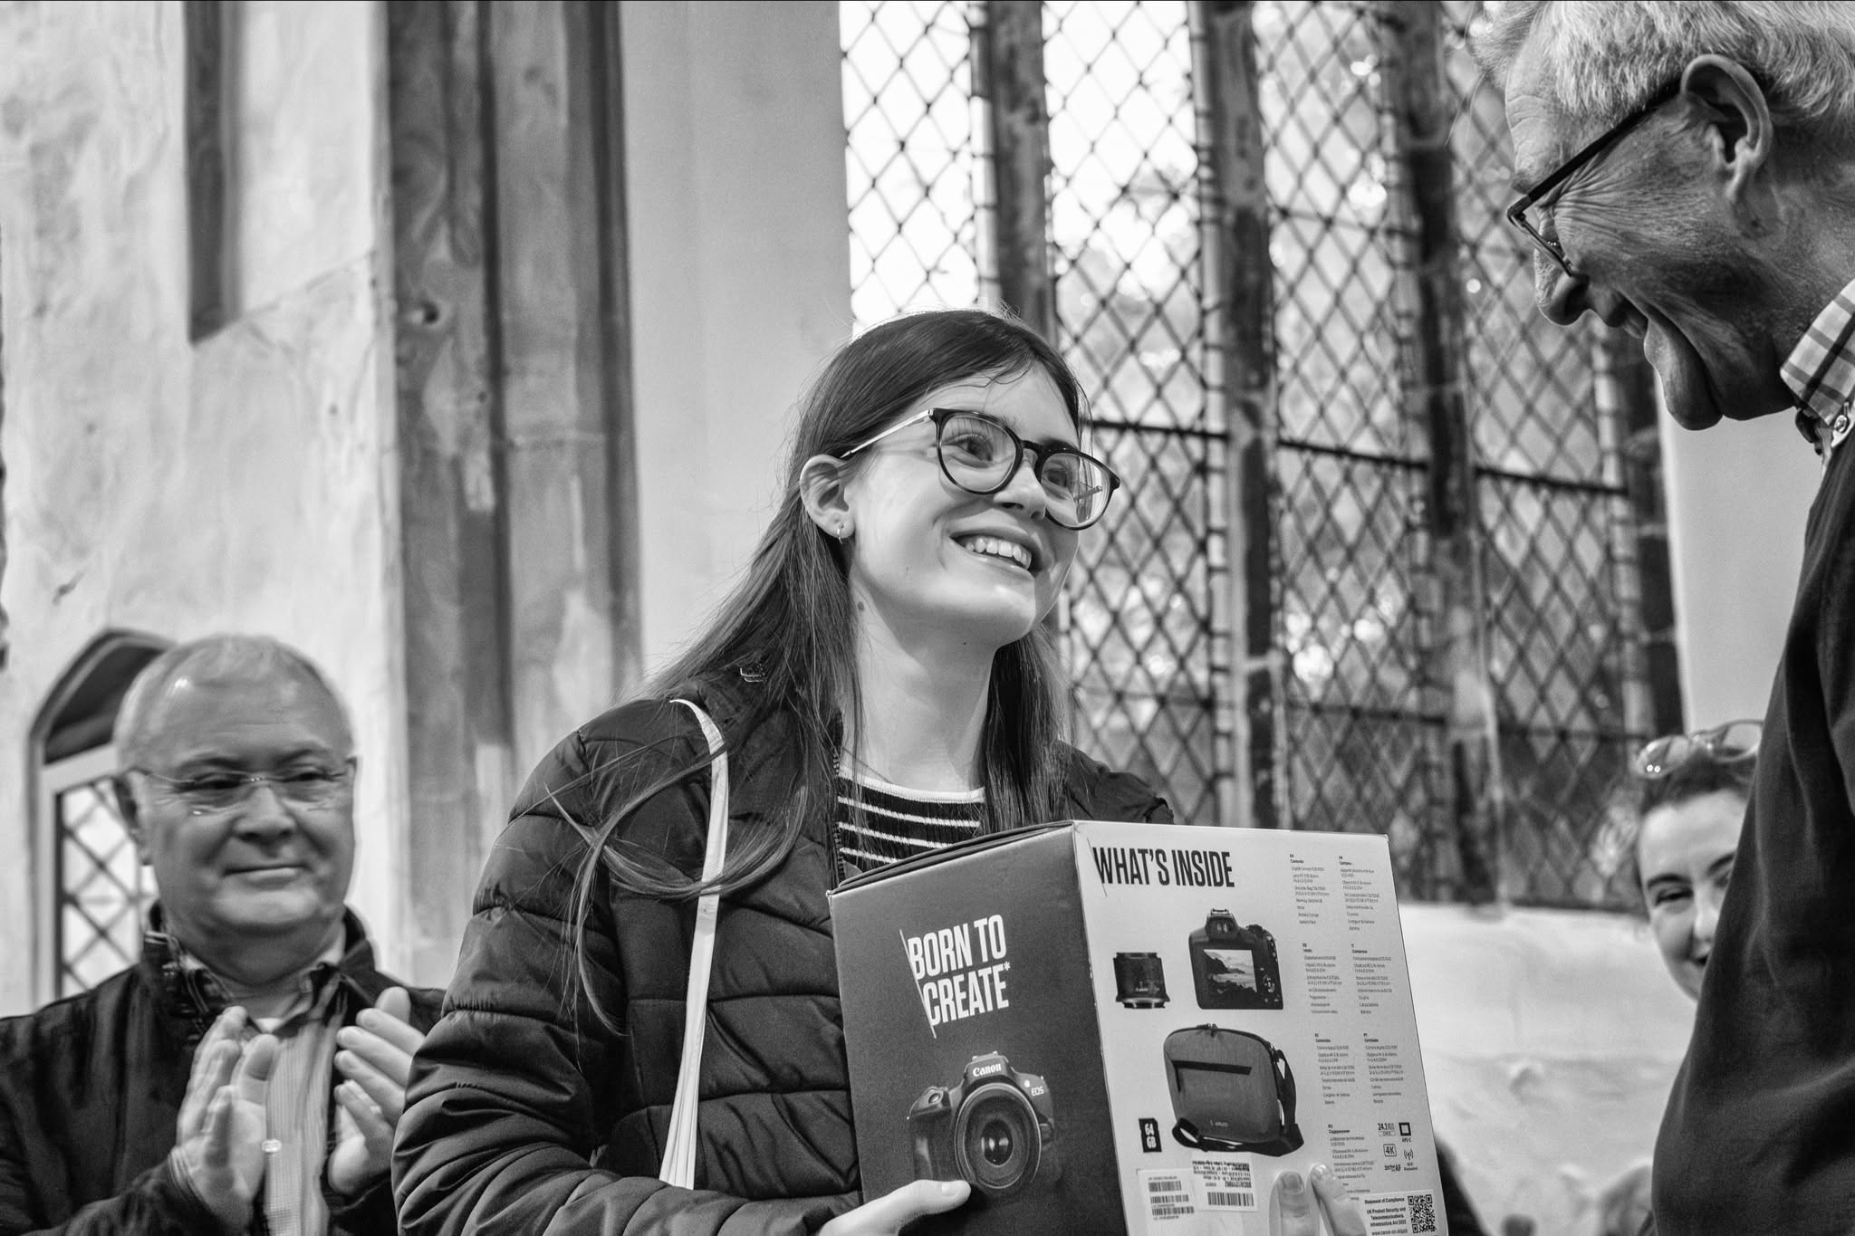
Under 16’s winner Emilia Wright, being presented with her prize by Roger Bellinger and Sophie Cabot. Left, Adult Category Winner Adrian Richmond congratulates Milly.

Shortlisted entries were then exhibited at Hungate Medieval Art in Norwich during Heritage Open Days in September 2025, and until the end of October - providing an opportunity for the public to view and celebrate the work of local photographers.

The top five photographs went on to be accessioned in Picture Norfolk, Norfolk County Council’s photographic archive of the county, which is publicly accessible via the Council’s Library and Information Service.

As part of the programme, a public lecture held on 20 September 2026 by Dr Clare Haynes, Claire Everiett (Picture Norfolk) and Jonathan Plunkett explored the importance of historic photographs as archaeological evidence, the development of photographic recording in Norfolk, and George Plunkett's remarkable contribution to documenting the county's heritage.

The Trustees intend the Plunkett Prize to become a biennial event, alternating with the Society's conference programme and providing a regular opportunity to engage new audiences through photography, exhibitions, and public events.

The Trustees wish to record their thanks to Jonathan Plunkett for his support and financial contribution for this event.

Norfolk Archaeology
Publication of the Norfolk Archaeology Journal remains one of the Society's most important charitable activities and is a significant contribution to archaeological scholarship.

In August 2025 the Society published volume three of the second series of Norfolk Archaeology, covering research undertaken during and up to 2024.

First published in 1846, the journal is one of Britain’s longest established archaeological publications and continues to provide an important forum for the publication of original research, excavation reports and historical studies relating to Norfolk.
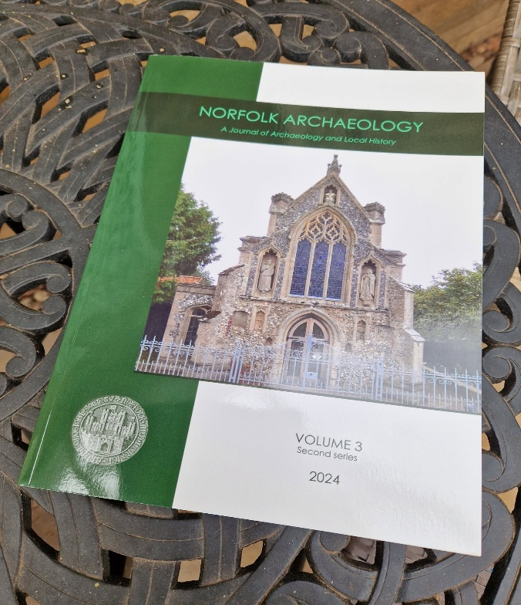

The main papers in Volume 3 cover:

- Late Neolithic, Bronze Age, and Iron Age activity at Hargham Road, Attleborough.
- A Beaker burial and Iron Age to Roman farmstead at Knights Hill, Kings Lynn.
- A Saxo-Norman to Medieval salt production site at Beacon Hill, Terrington St Clement.
- A medieval common-edge settlement south of Derham Road, Mattishall.
- Rediscovered medieval industry in Norwich.
- Excavations at 100 Benedicts Street, Norwich.
- The ruined church at North Elmham.
- Medieval pottery production in the Grimston area
- The “Slipper Chapel” at Houghton-St-Giles.
- The social background of Thomas Denys (died 1461).
- Richard Beatniffe and The Norfolk Tour.

The Trustees are grateful to all authors, reviewers and contributors who supported the production of the journal, and particularly to Dr Sue Anderson, Honorary Editor, whose expertise and dedication continue to maintain the journal's high academic standards.

NNAS Newsletter

The Society continued to keep members informed throughout 2025 through its twice-yearly newsletter, published in the spring and autumn. The newsletter provides an important means of communicating Society news, promoting forthcoming events, and sharing archaeological discoveries, field work reports and other items of local interest. It also features a regular ‘What’s On’ and ‘Further Afield’ events listing section, and joining information, allowing it to be used for membership recruitment.

During the year the newsletter also included short articles on projects supported by NNAS Grant funding, for instance the dendrochronological dating of Bylaugh church tower, the Archive Improvement Project at the Sedgeford Historical and Archaeological Society – and the ongoing work of the Caistor Roman Project.

The trustees want to thank Dr Claire Haynes for her work as Honorary Newsletter Editor and to acknowledge the contribution of Mike Pitacchio who began a planned handover of editorial responsibilities during the year.

Digital Communications

The Society's website (www.nnas.info) was updated regularly with information about lectures, excursions, publications, grants and other activities, ensuring that members and visitors could access up-to-date information and resources.

Monthly members’ update emails continue to provide timely information about forthcoming events, society news, and opportunities to become involved in the Society's work, as well as short notice reminders of events and activities. The Society continues to grow its email database, to make this mode of communication more effective.

The Society also maintained an active presence on social media. During the year its Facebook page remained well supported, with 1.9K followers, 13,711 views and a 301% increase in post engagement.

Whilst the Society has an X account, it is no longer active. In common with many heritage organisations, the Trustees keep the Society's use of social media under review as communication channels and user preferences continue to evolve.

Specialist Library

The Society’s specialist library is one of its most valuable resources, supporting archaeological research and has a wide collection of volumes from much of the country, mainly maintained by an exchange system with archaeological societies.

During 2025 the library continued to benefit from significant additions to its collections, with 170 new books acquired.

The Honorary Librarian continued to catalogue new acquisitions, respond to research inquiries and assist visitors using the collections. The Librarian also provides support through the Society's website by answering enquiries and helping researchers locate relevant publications and archive material.

The Society's library is housed within the Norfolk Record Office, and its current opening hours are published on the Society’s website.

The Trustees continue to seek an assistant librarian to support the long-term development and accessibility of the Society's collections.

Young Archaeologists Club (YAC)

The Society supports Norwich YAC, a branch of the national Young Archaeologists’ Club, run by the Council for British Archaeology.

A full programme of Saturday morning meetings was offered in the school year, October-July. Approximately 25-30 young people attended most meetings, and membership continued to grow throughout the year, reaching a new high of 41 members by the end of the year.

In 2025 the branch worked extensively with our sister organisation Norfolk Archaeological Trust, in their 100th anniversary project ‘NAT 100’. This included several visits to NAT sites, learning about the foundation of NAT by members of NNAS in the 1920’s, and helping to select items for an exhibition in the long gallery at Norfolk Record Office.

Additional sessions and independent research undertaken for the NAT 100 project allowed a number of members to complete their Bronze Level Heritage Heros Award.

Ther is a strong demand for YAC membership in Norfolk, and Norwich leaders were please to encourage the opening of a ‘YAC Associate Branch’ at Gressenhall Farm and Workhouse Museum in Dereham during the year, supporting 11-16 year olds.
A similar Associated Branch is active in Great Yarmouth, but the Trustees have begun discussions on how the Society might support the opening of a branch in the west of the county, if volunteers can be recruited.
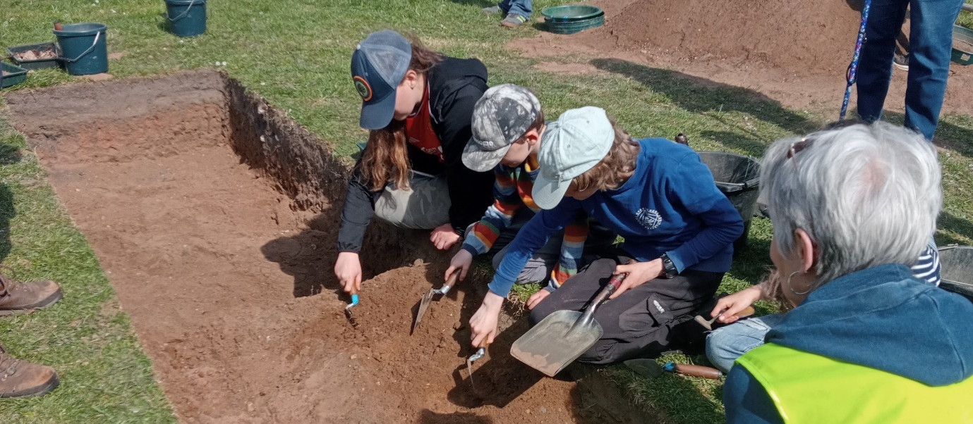
Norwich and Great Yarmouth YAC members on a dig at Great Yarmouth town walls.

Grants and contributions awarded

Supporting archaeological research, heritage conservation and public engagement across Norfolk remains one of the Society's principal charitable activities.

During 2025, the Trustees awarded grants and contributions totalling £6,320. Full details are provided in the notes to the Financial Statements.

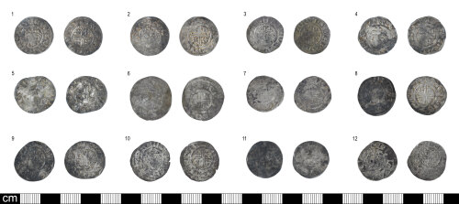
The Ovington coin hoard purchased by the Norfolk Museums Service from a grant given by NNAS

The largest grant, £2,500, enabled the Norfolk Museum Service to acquire the Ovington mediaeval coin hoard. Discovered by metal detectorists between December 2021 and February 2022, the hoard comprises 69 mediaeval silver coins dating from the late 12th to the early 13th century.

Unlike a curated collection of selected coins, the Ovington Hoard appears to reflect money in everyday circulation. Its many fractional coins show that whole pennies were cut for use in daily transactions.

The Society’s support ensured that this important archaeological discovery entered the county's public collections rather than being dispersed, assuring it is accessible to visitors, researchers, and future generations. It is now displayed in Norwich Castle Museum’s Gallery of Medieval Life, a collaborative exhibition space developed by Norfolk Museums Service in partnership with the British Museum and a central element of the transformation of Norwich Castle Keep which opened with national media attention on 7th August 2025.

The Society also made a £1,000 contribution to Norfolk County Council’s Communities and Environment Division to help fund a two-day 50 Years of Discovery conference held in November 2025. Day 1 of the conference focused on the past five decades of discovery in the east of England whilst day 2 explored what lays ahead through community-led heritage projects and emerging archaeological technologies.

In addition to these awards, grants were made to support archaeological research projects across Norfolk, including work on later prehistoric landscapes, World War 2 defences and environmental analysis associated with Arminghall Henge.

In 2025, the Society renewed its loan of the De Vere stained-glass roundel to the Stained Glass Museum at Ely Cathedral. First loaned in 2015, the agreement must be renewed every ten years. The 14th-century heraldic badge, made for John de Vere, 7th Earl of Oxford, depicts a wild boar. It remains on permanent display, with an image and further details available in the Museum’s online catalogue.

The Trustees continue to encourage applications that support archaeological research, publication, conservation, and public engagement, ensuring that the Society's resources deliver lasting benefits to Norfolk's heritage.

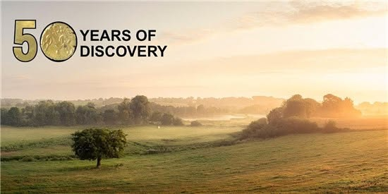
The 50 Years of Discovery conference in 2025. Copyright Norfolk County Council Environmental Services

- STRATEGIC REVIEW OF THE SOCIETY

During 2025, the Trustees commissioned an independent strategic review of the Society's governance, administration, and financial management to ensure that it remained well placed to deliver its charitable objectives effectively and sustainably into the future.

Mrs Rachel Kirk, a freelance consultant, was appointed in July 2025 to undertake the review. She examined the Society's governance arrangements, administrative systems, financial processes, use of resources and met with Trustees individually to obtain a wide range of viewpoints.

The review identified a number of opportunities to strengthen the Society's effectiveness, including:

- Increasing administrative capacity to support Trustees.
- Improving strategic planning and governance.
- Making better use of the Society's financial resources to advance its charitable objectives.
- Modernising record management and financial systems.
- Reducing reliance on manual administrative processes.

The Trustees considered the review’s recommendations in October 2025 and agreed a programme of improvements. These included the appointment of a part-time freelance Administrator, the introduction of cloud-based accounting software and online banking arrangements, the creation of a central digital filing system, and the transfer of routine administrative tasks from Trustees to the Administrator.

The review also led to the Trustees holding a strategic planning day in March 2026 to consider the Society's future priorities. The outcomes of that work are summarised in the following section of this report and will be fully reported on in the Annual Report for 2026.

- PLANS FOR FUTURE REPORTING PERIODS

The Trustees will continue to deliver the Society's established programme of lectures, excursions, publications, grants and support for archaeological research, while progressing a number of important new initiatives identified through the strategic review.

In 2026, the Society celebrates its 180th anniversary, marking 180 years since its foundation as the United kingdom's second oldest archaeological society. To celebrate this significant milestone and to promote the Society's charitable aims, the Society participated in the Norwich Science Festival and the Norwich History Festival. Further details of these activities will be reported in the 2026 Annual Report

The Society’s 180th anniversary conference, Exploring Norfolk's Past, took place on 10th October 2026. The programme included presentations on the Norfolk carnyx hoard, Romano-British pottery, recent discoveries from the Norwich Castle excavations, Norfolk's early parish churches and mediaeval landscapes, the Gloucester shipwreck, and the themes of archaeology and well-being.

Following the Trustees strategic planning away day in March 2026, work is now underway on a number of longer-term improvements, including:

- Strengthening member engagement and encouraging membership growth.
- Improving the Society's website and digital communications.
- Reviewing the grants programme to maximise public benefit.
- Developing the society's library and exploring opportunities for digitisation.
- Preparing a medium-term financial strategy to guide the use of the Society's investment assets in support of its charitable objectives.
- Bringing forward the timing of the Annual General Meeting to October, rather than December, to improve governance and reporting.

These initiatives will help ensure that the Society remains financially resilient, well governed, and able to continue promoting the archaeology, history and heritage of Norfolk for the benefit of its members and the wider public.

- FINANCIAL SUMMARY

The Financial Statements for the year ended 31st December 2025 are set out at the end of this Annual Report. The Independent Examiners report was published separately alongside the Financial Statements.

Financial performance

Pie chart showing the sources of income in 2025
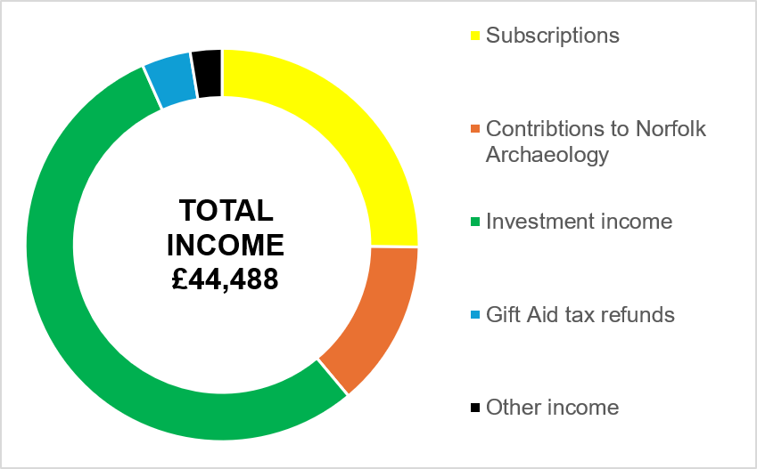

Total income for the year amounted to £44,488 (2024: £42,387), while total expenditure was £41,810 (2024: £33,433), resulting in an operating surplus before investment gains of £2,678 (2024: £8,954).

The lower operating surplus compared with the previous year principally reflects the Society's continued investment in advancing its charitable objectives. During 2025 this included the successful launch of the inaugural Plunkett Prize, which will now become a biennial feature of the Society's programme of public engagement, together with the commissioning of an independent Strategic Review to strengthen the Society's governance, administration, and long-term sustainability.

The Society continued to benefit from income generated by its investment portfolio. Investment income, together with interest earned on cash deposits and fixed term savings bonds, generated £24,226 during the year (2024: £22,211).

In addition, favourable investment markets resulted in realised and unrealized investment gains. Overall, the Society’s total funds increased by £53,489 to £785,382 (2024: £731,893), reflecting both the operational surplus generated from its activities and the performance of its investment portfolio.

Pie chart showing the breakdown of 2025 expenditure
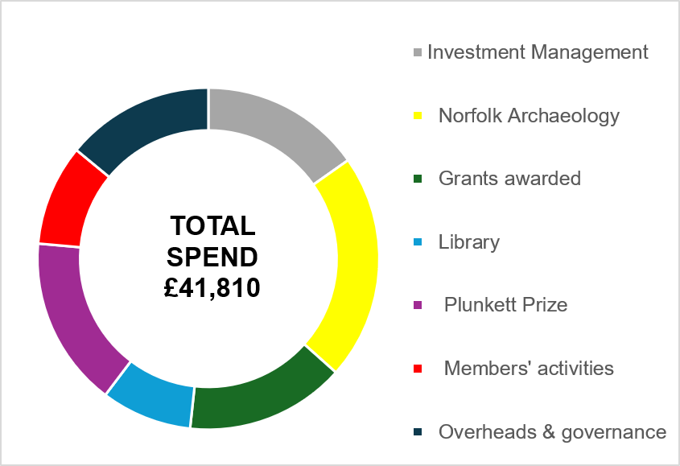

Cash and investments

At 31st of December 2025, the Society held cash deposits immediately available totalling £49,976 (2024: £45,948) comprising: Barclays Bank current account: £32,061 and Leeds Building Society Savings Account: £17,915.

The Society's investment portfolio, managed by Rathbones Investment Managers, had a market value of £702,232 at the year-end (2024: £657,756).

In addition, the Society had £20k invested in a 2-year fixed rate bond at 4.31% (maturing Feb 2027) and £10k in a 3-year savings bond at 4.11% (maturing Feb 2028), both with United Trust Bank

Reserves

At 31st of December 2025 the Society's unrestricted funds totalled £785,382 (2024: £731,893).

The Trustees have reviewed the level of reserves and considered them appropriate for the size and nature of the society's activities. The reserves provide financial resilience against fluctuations in income and investment markets, enable the Society to meet its ongoing commitments, support the publication of Norfolk Archaeology, maintain its grants programme, and provide the flexibility to invest in new initiatives that further its charitable purposes.

The Trustees aim to maintain reserves sufficient to enable the Society to continue operating effectively for a minimum period of three years should there be a significant reduction in income or other unforeseen financial pressures. The current level of reserves is considered appropriate to support this objective.

Investment policy

The Society's principal asset is its investment portfolio, which is held as unrestricted funds and managed on a discretionary basis by Rathbones Investment Managers in accordance with the Trustee Act 2000 and the Society's Investment Policy.

The investment objective is to achieve an appropriate balance between income and long-term capital growth whilst maintaining a level of risk consistent with the Society's charitable purposes and anticipated future requirements.

The Society’s Investment Policy contains the following paragraph:

“The Trustees reserve the right to exclude companies that carry out activities contrary to their aims or from holding particular investments which damage the Charity’s reputation. Trustees expect the fund manager to have considered the suitability of investments of the same kind as any particular investment proposed to be made or retained. “

The Trustees continue to monitor investment performance regularly with their investment managers to ensure that the portfolio provides an appropriate balance between income generation, capital growth and risk, while supporting the society's long term charitable objectives.

Going concern

Having reviewed the Society's financial position, cash resources, unrestricted funds, and investment portfolio, the Trustees are satisfied that the Society has adequate resources to continue its activities for the foreseeable future. Accordingly, the Financial Statements have been prepared on an ongoing concern basis.

- CONCLUSION

2025 was a year of achievement and renewal for the Norfolk and Norwich Archaeological Society. Alongside its established programme of lectures, publications, excursions, grants and support for archaeological research, the Society launched the inaugural Plunkett Prize and commissioned an important strategic review to help shape its future: laying the foundations for a programme of modernisation that is now being implemented.

As this report has been written in the summer of 2026, much of that work is already bearing fruit. New administrative arrangements have been introduced, financial systems have been modernised, and the Trustees have implemented their ambitious plans to celebrate the Society's 180th anniversary.

The Trustees are grateful to the Society’s members, volunteers, officers, journal contributors, and lecturers, whose commitment and enthusiasm continue to make the Society's work possible.

As the Society celebrates its 180th anniversary, the Trustees look forward with confidence to building on this remarkable legacy, ensuring that the Society continues to inspire, support and promote the archaeology, history and heritage of Norfolk for the next 180 years.

Heather Wallis - President
Sophie Cabot - Honorary General Secretary
Karen Watling - Honorary Treasurer

NORFOLK & NORWICH ARCHAEOLOGICAL SOCIETY

STATEMENT OF FINANCIAL ACTIVITIES FOR THE YEAR ENDED 31 DECEMBER 2025
 | Note | 2025 | 2024
 |  | £ | £
INCOME FROM:
Donations, Subscriptions and Gift Aid
- Donations |  | 350 | 72
- Membership subscriptions |  | 11,196 | 9,514
- Gift Aid |  | 1,785 | 1,499
Income from Charitable Activities
- Contributions to Norfolk Archaeology | 2 | 6,120 | 8,820
- Sale of publications |  | 324 | 29
- Sale of excursions & 2024 Conference tickets |  | 237 | 242
- Contribution to the 2025 Plunkett Prize | 3 | 250 | 0
Income from Investments | 4 | 24,226 | 22,211
Total Income |  | 44,488 | 42,387
EXPENDITURE ON:
Raising Funds | 4 | 6,367 | 6,189
Charitable Activities
- Publication of Norfolk Archaeology | 2 | 8,935 | 8,251
- Grants and Contributions awarded | 5 | 6,320 | 8,000
- 2025 Plunkett Prize | 3 | 6,735 | 0
- Library Operational Expenditure | 6 | 3,591 | 3,995
- Members’ Activities | 7 | 3,993 | 3,520
- Overhead and Governance costs | 8 | 5,869 | 3,478
Total Expenditure |  | 41,810 | 33,433
Net operational Income / (expenditure) before investment gains / (losses) |  | 2,678 | 8,954
Realised surplus / (loss) on sale of investments |  | 3,108 | (8,309)
Unrealised surplus / (loss) on revaluation |  | 47,703 | 35,774
NET MOVEMENT IN FUNDS |  | 53,489 | 36,419
TOTAL FUNDS BROUGHT FORWARD |  | 731,893 | 695,474
TOTAL FUNDS CARRIED FORWARD |  | £785,382 | £731,893
NB All income and expenditure is unrestricted and relate to continuing charitable activities.
NORFOLK & NORWICH ARCHAEOLOGICAL SOCIETY

BALANCE SHEET AS AT 31 DECEMBER 2025

 | Note | 2025 | 2024
 |  | £ | £
LONG TERM INVESTMENTS:
- Managed Funds | 9 | 702,232 | 657,756
- United Trust Bank Fixed Term Savings Bonds |  | 30,000 | 20,000
 |  | 732,232 | 677,756
CURRENT ASSETS:
Debtors
- Gift Aid recoverable |  | 1,785 | 1,499
- Accrued investment income |  | 1,103 | 6,108
- Contributions to Norfolk Archaeology |  | 2,220 | 2,040
- Subscriptions in arrears |  | 385 | 0
Cash at bank and in hand
- At Barclays Bank current account |  | 32,061 | 28,368
- At Leeds Building Society instant access |  | 17,915 | 17,580
 |  | 55,469 | 55,595
CURRENT LIABILITIES:
Creditors
- Subscriptions in advance |  | 385 | 708
- Norfolk Archaeology costs |  | 0 | 0
- Grants awarded but not yet paid |  | 1,730 | 750
- Independent Examiner’s Fees |  | 204 | 0
 |  | 2,319 | 1,458
NET ASSETS |  | 785,382 | 731,893
Represented by:
UNRESTRICTED FUNDS |  | £785,382 | £731,893

The notes on pages 21 to 24 form part of these Financial Statements.

The Financial Statements were approved by the Trustees on (8/09/2026) and signed on their behalf by:

Heather Wallis
President and Trustee
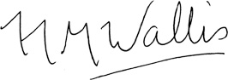……………………. (9/09/2026)

Sophie Cabot
Honorary General Secretary and Trustee
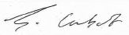

………………………………………………. (9/09/2026)

NORFOLK AND NORWICH ARCHAEOLOGICAL SOCIETY

NOTES TO THE ACCOUNTS – YEAR ENDED 31 DECEMBER 2025

- ACCOUNTING POLICIES

- These Financial Statements have been prepared in accordance with the Charities Act 2011, the Charities SORP (Statement of Recommended Practice), and the Financial Reporting Standard (FRS 102) applicable in the United Kingdom and Republic of Ireland to give a “true and fair” view of the Society’s financial position and performance.

- All income is recognised once the Society has entitlement to the income, it is probable that the income will be received, and the amount of income receivable can be measured reliably.

- Expenditure is recognised on an accruals basis once there is a legal or constructive obligation to transfer economic benefit to a third party, it is probable the transfer will occur, and the amount of obligation can be measured reliably. Expenditure is classified by activity and is inclusive of irrecoverable VAT.

- At the time of approving the Statement of Accounts the Trustees had a reasonable expectation that the Society has adequate resources to continue as a going concern in the foreseeable future. The Trustees have therefore adopted the going concern basis of accounting in preparing the financial statements.

- Investments are stated at their market value at the Balance Sheet date. Net gains or losses on revaluation and disposals throughout the year are combined and shown within the Statement of Financial Activities (SOFA). The Society does not hold any restricted or endowment investment portfolios: all investments are held to generate an unrestricted return for general charitable purposes and are available for use at the discretion of the Trustees in furtherance of the general objectives of the Society.

- In preparing these statements the Trustees have had regard to the professional advice provided by Rathbone’s Investment Managers regarding the market value of the Society’s portfolio of investments. The valuation has been prepared on the basis of mid-market prices from the appropriate Stock Exchange, market makers, or from the relevant fund manager.

- NORFOLK ARCHAEOLOGY JOURNAL

 | 2025 | 2024
 | £ | £
Typesetting | 1,890 | 1,480
Printing and distribution | 7,045 | 6,771
Total expenditure | 8,935 | 8,251
Less contributions received | (6,120) | (8,820)
NET COST / (SURPLUS) | £2,815 | £(569)

The Journal costs and income for 2025 relate to Volume 3 of the second series, covering the year 2024, which was published and distributed in August 2025.
NORFOLK AND NORWICH ARCHAEOLOGICAL SOCIETY

NOTES TO THE ACCOUNTS – YEAR ENDED 31 DECEMBER 2025 (continued)

- 2025 PLUNKETT PRIZE

 | 2025 | 2024
 | £ | £
Competition setup legal advice | 1,200 | 0
Publicity and promotion | 2,977 | 0
Cost of prizes | 1,914 | 0
Venue hire and events | 644 | 0
Total expenditure | 6,735 | 0
Less sponsorship received | (250) | 0
NET COST | £6,485 | £0

The Society gratefully acknowledges a donation of £250 from Jonathon Plunkett towards the costs of the inaugural Plunkett Prize.

- INVESTMENT INCOME

 | 2025 | 2024
 | £ | £
Interest from Leeds Building Society | 335 | 414
Interest from United Trust Bank fixed rate savings bonds | 2,088 | 0
Income from managed investment portfolio | 21,803 | 21,797
TOTAL IINVESTMENT NCOME | £24,226 | £22,211

Investment management fees payable to Rathbones Investment Management totalled £6,367 (2024: £6.189). These are included within Raising Funds in the Statement of Financial Activities.

- GRANTS AND CONTRIBUTIONS AWARDED

In 2025 the Trustees awarded grants totalling £5,320, including a grant to the Norfolk Museums Service to acquire the Ovington mediaeval coin hoard. At 31st December 2025, the grant awarded for pollen analysis at Arminghall Henge remained unpaid, together with the outstanding grant of £750 awarded in 2024 for dendrochronology tests at Bylaugh Church.

In addition, the Society contributed £1,000 to Norfolk County Council’s Community and Environment Division for their 50th anniversary conference held in November 2025.

NORFOLK AND NORWICH ARCHAEOLOGICAL SOCIETY

NOTES TO THE ACCOUNTS – YEAR ENDED 31 DECEMBER 2025 (continued)

Grants and contributions awarded in 2025:

 | 2025
 | £
Ovington coin hoard purchase | 2,500
Warham Camp C14 dating | 1,440
Thetford WW 2 defences research | 400
Arminghall Henge pollen analysis | 980
 | 5,320
Contribution to the NCC Community and Environment Division | 1,000
TOTAL GRANTS & CONTRIBUTIONS AWARDED | £6,320

- LIBRARY OPERATIONAL EXPENDITURE

 | 2025 | 2024
 | £ | £
Premises rental paid to the Norfolk Record Office | 2,500 | 2,500
Book purchases | 96 | 374
Librarian’s Expenses | 995 | 1,011
IT costs | 0 | 110
TOTAL EXPENDITURE | £3,591 | £3,995

- MEMBERS’ ACTIVITIES

 | 2025 | 2024
 | £ | £
Printing and distribution of Members’ Newsletters | 2,314 | 3,194
Summer excursions’ programme | 120 | 196
Lecture Series – premises rental & lecturer costs | 1,559 | 130
 | 3,993 | 3,520
Less excursion ticket income | (237) | (242)
NET COST | £3,756 | £3,278

- OVERHEAD AND GOVERNANCE COSTS

 | 2025 | 2024
 | £ | £
Public liability and Indemnity Insurance | 568 | 483
Trustee and officers’ expenses | 229 | 356
Freelance administrative assistance | 885 | 537
Web site, software, STRIPE and other IT costs | 493 | 930
Accountancy fees for Annual Statements preparation | 0 | 300
Independent Examiners Fee | 204 | 378
Subscriptions to other Archaeological organisations | 540 | 494
Strategic Review of the Society | 2,950 | 0
TOTAL EXPENDITURE | £5,869 | £3,478

NORFOLK AND NORWICH ARCHAEOLOGICAL SOCIETY

NOTES TO THE ACCOUNTS – YEAR ENDED 31 DECEMBER 2025 (continued)

The strategic review was commissioned by the Trustees during 2025 to support the Society's long-term governance, administration, and strategic development.

The 2025 Financial Statements were prepared by the Honorary Treasurer who is a qualified accountant, so no expenditure was incurred on external accountancy fees.

9. VALUATION OF THE EXTERNALLY MANAGED INVESTMENT PORTFOLIO

The bulk of the Society’s assets are invested under the discretionary management of Rathbones Group PLC. Movements on the managed fund during 2025 as reported by the managers, were as follows:

 | COST | MARKET VALUE
 | £ | £
Opening Balance as at 1st January 2025 | 569,549 | 657,756
Cash introduced | 0 | 0
Realised gain / (loss) on disposal of investments | 3,108 | 3,108
Management fees paid from invested funds | (6,367) | (6,367)
Capitalised interest | 32 | 32
Unrealised gain / (loss) in values | 0 | 47,703
CLOSING BALANCE AS AT 31ST DECEMBER 2025 | £566,322 | £702,232

The net surplus on sales of £3,108 and the increase in market values of £47,703 have been recognised in the Statement of Financial Activities.

