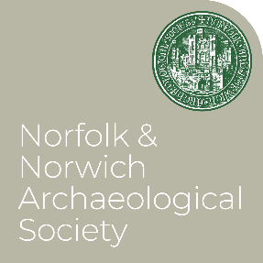
NNAS Winter Lectures 2026/7

All lectures are held at the Town Close Auditorium, Norwich Castle Museum, starting at 2.15pm. It is not necessary to pay museum admission, please just mention that you are attending the talk. Free to members, donations requested from non-members - or join NNAS at any event!
NNAS Lectures are also livestreamed via Microsoft Teams. To join online please register on the link provided below. NB: You must register separately for each lecture you wish to attend.

2026
3rd October
Sophie Cabot BA MPhil, Hon.Gen.Sec of NNAS: ‘180 years of the NNAS’ REGISTER HERE

(This lecture will be preceded at 1pm by the 180th AGM of the Society. Register HERE. There will be a comfort break between the two events.)

7th November
Dr Lawrence Billington, project officer Oxford Archaeology: ‘Prehistory on the Sizewell C excavations’ (joint meeting with the Prehistoric Society) REGISTER HERE

5th December
Ruth Brennan, architect. ‘A major conservation project at Baconsthorpe Castle’
(joint meeting with NAHRG) REGISTER HERE

2027

9th January
Dr Clare Haynes and Professor Sandy Heslop: ‘Medieval Churches of the City of Norwich’
REGISTER HERE

6th February
Candy Hatherley, Project Portfolio Manager, Headland Archaeology: ‘Necton Roman Villa’
REGISTER HERE

6th March: The Sue Margeson Memorial Lecture 2027
Dr Alexandra Makin, Specialist in early medieval embroidery. ‘Early medieval embroidery and textiles’ REGISTER HERE

(Please note, some titles in this list are provisions, and will be updated as more information becomes available.)

